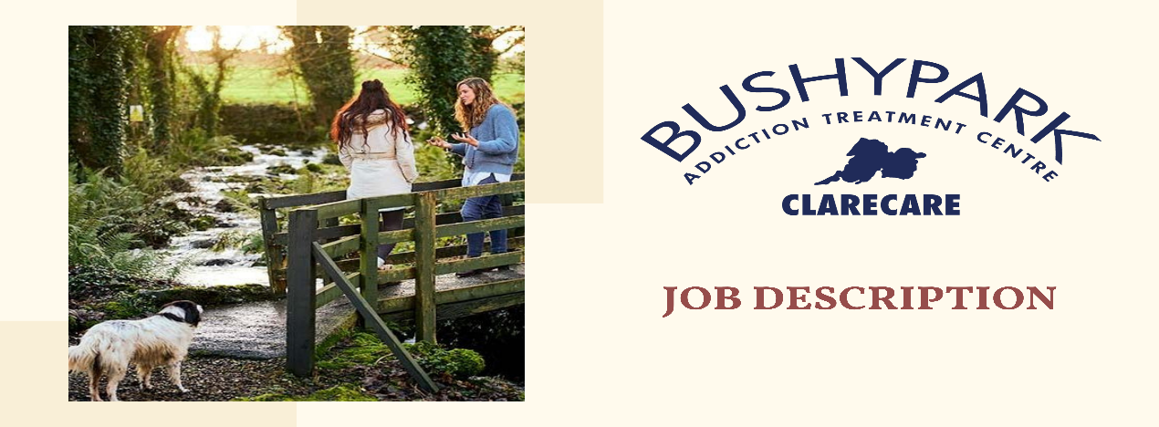

Clarecare is a professional social enterprise with charitable status, providing a range of people centred social services to individuals and families in County Clare for over 50 years. Current services provided include Family Support, Elderly Care Services, Counselling and Bushypark Residential Addiction Treatment Centre. Clarecare’s headquarters are based in Ennis with local offices in Bushypark, Shannon, Kilrush, Killaloe and Ennistymon. Further information is available on www.clarecare.ie www.bushypark.ie

Bushypark Residential Treatment Centre is a Clarecare service, offering a 28-day Residential Programme for people with alcohol, drugs, gambling, and other addictions, based on evidence based models of treatment. In addition to residential treatment, the Centre also offers Community based Programmes, Family Supports and Aftercare. For more details and other service, please visit: www.bushypark.ie

Bushypark is supported by HSE Alcohol and Drug Services, MWRDAF, Probation Service, HSE Mental Health Service and other local funders.

In conjunction with a significant capital investment expansion project at Bushypark Treatment Centre, we now have two hugely exciting opportunities to join our Counselling Team on a full-time permanent basis.

Overview of Bushypark Addiction Treatment Centre:
The Counsellor position forms part of a multi-disciplinary team, led by a Psychotherapist/Clinical Supervisor in conjunction with a Consultant Psychiatrist. The existing team includes Addiction Counsellors, Psychotherapists and Night Staff who work on a full-time or part-time basis. Counsellors are employed in both the residential and community-based services within the Service.

As an integral Service within Clarecare, Bushypark Addiction Treatment Centre provides a range of services for people impacted by addiction and other health and societal related issues within the Mid-West and wider geographical regions. Bushypark has established and enhanced links nationally and internationally in the development of its ongoing programmes.

Bushypark has secured significant financial funding to expand its current facility and to re-develop Bushypark House, thus enabling the Service to increase its in-house capacity to 16 residents in addition to enhancing our community-based services to meet a growing demand within the region and beyond.

We are also expanding and refurbishing our Family Centre on the grounds of Bushypark, thus enabling the expansion of services to support clients and family members with addiction related issues.

We are planning to develop further services in the areas of dual diagnosis and related aftercare and enhance online counselling services. As one of the few services that work with clients with dual diagnosis, Bushypark acknowledges the impact Covid-19 has had on mental health and the increased levels of addiction within the community. We have identified a need to further expand service provision in this regard.

The impact of Covid-19 has highlighted the requirement for online service provision. This has provided an opportunity for us to continue to expand this online service, especially to those in rural communities or to those who are unable to access face to face service provision.

The other area for expansion is Family Support services. Bushypark provides support to concerned persons across its services, from our confidential phone line to our aftercare programmes. As a result of funding secured from HSE through the Mid-West Regional Drug and Alcohol Forum, we are in a position to deliver Family Support Programmes in Ennis, Limerick and in Bushypark. Additional Family Support is provided on-line and by phone to meet individual family needs.

As stated earlier, Bushypark works in conjunction with a number of Voluntary and Statutory Agencies both in terms of funding and also in working with clients collectively. We are part of both local and national fora and working groups thus ensuring that we remain at the forefront of programme delivery and are committed to improve the quality of our evidence based Treatment Programme interventions.

Bushpark has well developed working relationships with Medical Insurance Providers (VHI, LAYA, Irish Life), the HSE Mental Health Service, HSE Addiction Services, Probation Service, Local Employers and a range of other services who support our clients to access both the residential and community-based projects. Bushypark has long established links with Clare Local Development Company, Clare Local Sports Partnership, MWRDAF and other services to deliver aspects of our programmes.

Further information is available on www.bushypark.ie www.clarecare.ie

JOB DESCRIPTION

TITLE: Counsellor – Full-time, Permanent role

ROLE: In conjunction with a significant capital investment expansion project at Bushypark Treatment Centre, we now have two hugely exciting opportunities to join our Counselling Team based in Ennis, Co. Clare. The successful candidates will work as part of the clinical team in providing assessment, evaluation and psychological interventions as appropriate to individuals, couples and families who present to the service for support with addiction and related issues. You will case manage individuals within the centre during treatment episodes.

JOB RELATIONS: The Counsellor will work as part of the Bushypark Team and will report to and be supported by the Bushypark Team Leader with dotted line reporting to the Centre Manager or designate.

JOB LOCATION: The Counsellor will be based in the Bushypark Addiction Treatment Centre, Ennis, Co. Clare.

JOB DETAILS: The successful candidate will work as part of the Treatment Team in Bushypark and liaise regularly with same. Flexibility and willingness to travel and work outside of normal hours is necessary. Training and supervision will be provided to the successful candidate.

HOURS OF WORK: This is a full-time permanent role (subject to probationary period and continued funding) working 40 hours per week over a 7 days rota which includes working 1 Saturday and 1 Sunday (alternate) in every 6 weeks cycle.
Every 6 weeks the person works a Saturday (12 hours) and the following week a Sunday (12 hours). When working the weekend (see above), staff will have the prior Friday and following Monday off.

Regular rota times are 8am-4pm, 9am-5pm or 1pm-9pm. Saturday and Sunday are from 9am-9pm. You will receive advance notice of rostered hours of work.

RESPONSIBILITIES OF THE POSITION:
General Responsibilities:
- To be accountable to the Bushypark Team Leader or designate.
- To adhere to both Clarecare and Bushypark policies and procedures in relation to your work.
- To maintain files in accordance with CHKS accreditation standards in order to ensure that good record keeping practices are in place.
- To fulfil the administrative responsibilities of the post.
- To complete statistics as required by the line manager.
- To maintain professional boundaries in all work with clients
- To comply with the clinical standards of the Centre
- To support the work of staff, volunteers, students and others involved in Bushypark and Clarecare.
- To actively participate in regular external personal supervision as required by your accrediting body and provide receipt of attendance.
- To actively participate in in-house team monthly supervision.
- To engage in in-house and other relevant training and to keep up to date with new developments in addiction, counselling and psychotherapy.
- To perform such other duties appropriate to the office as may be assigned to you by the Bushypark Team Leader or designate.
Principal Duties and Responsibilities:
Clinical Practice :
- One to one work with clients with addiction issues and their concerned persons.
- Developing individual strategies and care plans with residents in the centre.
- Developing aftercare plans with residents and family members.
- Facilitating group sessions and family conferences.
- Carrying out clinical screening, assessments and intakes with clients.
- Liaising with referral agencies and other relevant services.
- Preparation and delivery of lectures to resident groups and family groups.
- Case managing clients where necessary in line with NDRIC.
- Working as part of a multi-disciplinary team and on own initiative.
- Support clients and concerned persons pre and post treatment via phone / on-line platforms.
- Support the Bushypark Aftercare Programme and volunteers.
- Development of progression routes for clients including referrals to self-help groups, community initiatives and other specialised services
- Participate in Clinical Multi-disciplinary Team meetings and liaise with GP’s and/or other primary health care staff, Psychiatric Services, Statutory/Voluntary and other agencies as required.
- Observe professional ethical standards and behaviours as required by Bushypark/Clarecare policies and guidelines e.g. Children First, Safeguarding Vulnerable Persons at Risk of Abuse, Freedom of information Act, Data Protection Act, etc and requirements of relevant Professional Accrediting Bodies, ensuring confidentiality of records and security of same.
- Maintaining relevant records and files as required by Bushypark and Clarecare.
- Facilitate and participate in clinical audits and quality audit projects when required.
- Be responsible for the overall running of the Centre while on duty at evenings/weekends.

Essential Requirements:

- A professional qualification in Counselling or Psychotherapy to at least Level 7 on the Irish National Framework of Qualifications (NFQ) - QQI
OR
- Have an equivalent qualification and full registration from another jurisdiction.
AND
- Be fully accredited as a Counsellor with Addiction Counsellors of Ireland (ACI) or as a Counsellor/Psychotherapist with the Irish Association of Counsellors and Psychotherapists (IACP) or a relevant body within the Irish Council for Psychotherapy (ICP).
AND
- A minimum of 2 years post qualification experience working as an accredited Counsellor in a clinical setting, with individuals and/or groups where addiction issues are part of your work experience.
AND
- Candidates must possess the requisite knowledge and ability (including a high standard of suitability and management ability) to ensure the proper discharge of the responsibilities of these roles.
- Working knowledge of the Biopsychosocial model of addiction treatment.
- Excellent communication (both written and verbal) and interpersonal skills with the ability to work on own initiative and as part of a team.
- Excellent facilitation and group work skills.
- Well-developed computer skills i.e. MS Word, Excel and Outlook to facilitate you devising reports and care plans, etc.
- Excellent organisation and planning skills.
- Be committed to his/her continuous professional development (CPD).
- Be willing to work one Saturday and one Sunday on alternative weeks in every 6 weeks period,
- Ability to maintain the principles of confidentiality in all areas of work.
- 2 positive references from current/most recent paid employment.
- Positive current Garda Vetting Disclosure via Clarecare.
- Undertake a Pre-employment Medical Assessment
- Undertake any other relevant duties as assigned.
- Full clean driving licence.

Salary/Grade:
The gross salary & benefits on offer for this position is commensurate with experience and is available upon request from Carmel Keane, HR Manager on 086 - 4161520.

NOTE: The foregoing contains an outline of the main duties and cannot be complete. You will be required to respond flexibly when ad hoc tasks arise which are not specifically covered in this job description. This includes additional duties which may arise from future legislation affecting the Charities sector.

